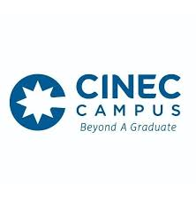 | Ethics Review Committee CINEC Campus
 | CV of the Applicant

Personal Information

Name |  | Rev/Prof/Dr/Ms/Mr
Current Designation
Home Address
Contact Number
Email address
Educational/Professional Qualifications

Bachelor’s degree
Postgraduate degrees
Work Experience
Employment | Designation |  | Work place | Period
Present
Previous 1
Previous 2
Publications (list up to 5 most relevant to the proposed study)
Ongoing Research Projects (other than this project)
Date: ____________________________ Signature of the Applicant: ____________________________

